**Classification Based on Energy Bands**

Bohr’s model of the [atom](https://www.toppr.com/guides/chemistry/atoms-and-molecules/what-is-an-atom-and-how-do-atoms-exist/) states that the energy of an [electron](https://www.toppr.com/guides/physics/current-eletricity/drift-electrons-origin-resistivity/) is determined by the orbit in which it revolves. This is true for an isolated atom. In a solid, atoms are close together. Therefore, electrons from neighbouring atoms come very close even overlap at times. Hence, the motion of an electron is different in a solid as compared to an isolated atom. In an atom, electrons in the innermost orbits, which are filled are called Valence electrons. On the other hand, electrons in the outer orbits that do not fill the shell completely are called Conduction electrons. In a [crystal](https://www.toppr.com/guides/chemistry/the-solid-state/close-packing-in-crystals/), every electron has a unique position and different pattern of surrounding [charges](https://www.toppr.com/guides/physics/some-natural-phenomena/introduction-to-charges/). Hence, each electron has a different energy level. These energy levels with a continuous variation of energy form the Energy bands. The energy band which includes the energy levels of the valence electrons is called Valence band. Also, the energy band above it is called Conduction band. If there is no external [energy](https://www.toppr.com/guides/physics/current-electricity/electrical-energy-power/) supplied, then the valence electrons stay in the valence band. Now, electrons move from the valence band to the conduction band when the lowest level in the conduction band is lower than the highest level in the valence band. Usually, the conduction band is empty.

**Classification of Metals, Semiconductors, and Insulators**

* In case of metallic conductors, conduction band overlaps on the electrons in the valence band.
* In insulators, there is a large gap between both these bands. Hence, the electrons in the valence band remain bound and no free electrons are available in the conduction band.
* Semiconductors have a small gap between both these bands. Some valence electrons gain energy from external sources and cross the gap between the valence and conduction bands. By this movement, they create a free electron in the conduction band and a vacant energy level in the valence band for other valence electrons to move. This creates the possibility of conduction.

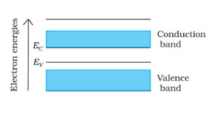

Ec denotes the lowest energy level of the conduction band and Ev denotes the highest energy level of the valence band. The above diagram describes a solid where the valence band is partially empty. Hence, electrons from the lower energy levels can move to the higher levels making conduction possible. Also, the resistivity of such solids is low or the conductivity is high.

**Metals**

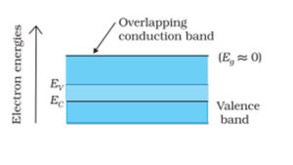

Ec and Ev are the same as case 1 and Eg is the energy gap. This diagram describes a solid where the conduction and valence bands overlap each other. Hence, electrons can easily move from the valence to the conduction band. This makes a large number of electrons available for conduction. Also, the resistivity of such solids is low or the conductivity is high.

**Insulators**

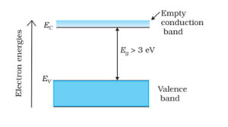

This diagram describes a solid where the energy gap (Eg) is very large (>3 eV). Due to this large gap, electrons cannot be excited to move from the valence to the conduction band by thermal excitation. Hence, there are no free electrons in the conduction band and no conductivity. These are insulators.

**Semiconductors:**

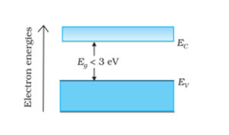

This diagram describes a solid where the energy gap is small (< 3 eV). Since the gap is small, some electrons acquire enough energy even at room temperature and enter the conduction band. These electrons can move in the conduction band increasing the conductivity of the solid. These are semiconductors. The resistivity of semiconductors is lower than that of insulators but higher than that of metals.

**Types of Semiconductors**

Semiconductors are mainly classified into two categories:

1. Intrinsic Semiconductor

2. Extrinsic Semiconductor

**Intrinsic Semiconductor:**

An intrinsic semiconductor material is chemically very pure and possesses poor conductivity. It has equal numbers of negative carriers (electrons) and positive carriers (holes).

**Extrinsic Semiconductor:**

Whereas an extrinsic semiconductor is an improved intrinsic semiconductor with a small amount of impurities added by a process, known as doping, which alters the electrical properties of the semiconductor and improves its conductivity. Depending on whether the added impurities have “extra” electrons or “missing” electrons determines how the bonding in the crystal lattice is affected as shown in figure, and therefore how the material’s electrical properties change.

|  |  |
| --- | --- |
| Image result for n-type impurity diagram | Image result for n-type impurity diagram |

N-type P-type

**Doping of Semiconductors:**

The addition of a small percentage of impurity atoms in the intrinsic semiconductor (pure silicon or pure germanium) produces dramatic changes in their electrical properties. Depending on the type of impurity added, the extrinsic semiconductors can be divided in to two classes:

1. N-type Semiconductors

2. P-type Semiconductors

**N-Type Semiconductor**: Group V dopants are the atoms with an “extra” electron, in other words a valence shell with only one electron. When a semiconductor is doped with a Group V impurity it is called an n-type material, because the addition of these pentavalent impurities such as antimony, arsenic or phosphorous contributes free electrons, greatly increasing the conductivity of the intrinsic semiconductor. In an n-type semiconductor, the majority carrier, or the more abundant charge carrier, is the electron, and the minority carrier, or the less abundant charge carrier, is the hole. The effect of this doping process on the relative conductivity can be explained by energy band diagram shown in figure. When donor impurities are added to an intrinsic semiconductor, allowable energy levels are introduced at a very small gap below the conduction band, as illustrated in figure. These new allowable levels are essentially a discrete level because the added impurity atoms are far apart in the crystal structure and hence their interaction is small. In the case of Silicon, the gap of the new discrete allowable energy level is only 0.05 eV (0.01 eV for germanium) below the conduction band, and therefore at room temperature almost all of the "fifth" electrons of the donor impurity are raised into the conduction band and the conductivity of the material increases considerable.

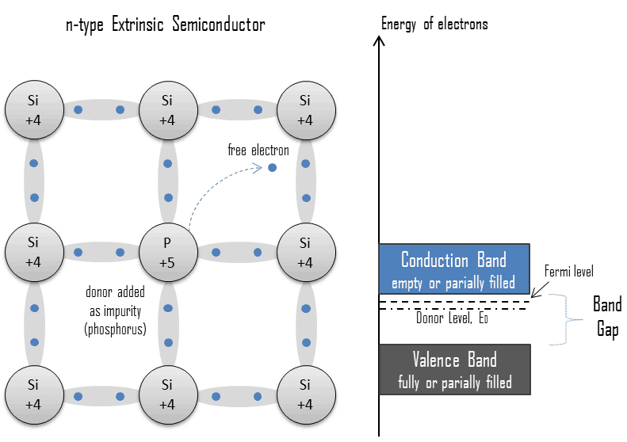

**P-Type Semiconductor**:

Group III dopants are the atoms with a hole in their valence shell (only “missing” one electron), When a semiconductor is doped with a Group III impurity it is called a p-type material, The addition of these trivalent impurities such as boron, aluminum or gallium to an intrinsic semiconductor creates deficiencies of valence electrons, called "holes". In an p-type semiconductor, the majority carrier, or the more abundant charge carrier, is the hole, and the minority carrier, or the less abundant charge carrier, is the electron. The effect of this doping process on the relative conductivity can be explained by energy band diagram shown in figure. When accepter impurities or P type impurities are added to the intrinsic semiconductor, they produce an allowable discrete energy levels which is just above the valance band, as shown in figure. Since a very small amount of energy (0.08 eV in case of Silicon and 0.01 eV in case of Germanium) is required for an electron to leave the valence band and occupy the accepter energy level, holes are created in the valence band by these electrons.

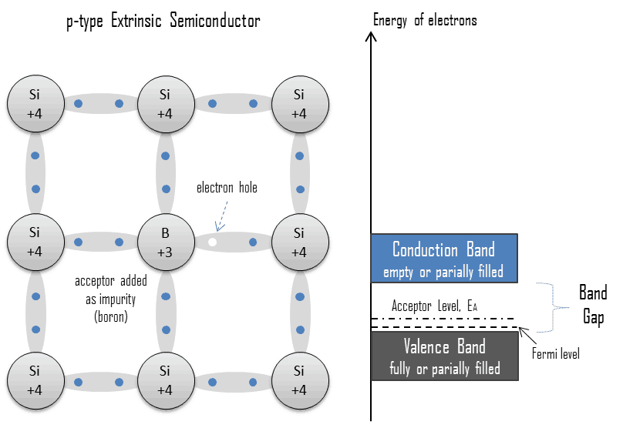

**Difference Between Intrinsic and Extrinsic Semiconductor**

|  |  |
| --- | --- |
| **Intrinsic Semiconductors** | **Extrinsic Semiconductors** |
| 1 It is pure semi-conducting material and no impurity atoms are added to it. | 1. It is prepared by doping a small quantity of impurity atoms to the pure semi-conducting material. |
| 2 Examples: crystalline forms of pure silicon and germanium. | 2. Examples: silicon “Si” and germanium “Ge” crystals with impurity atoms of As, Sb, P etc. or In B, Aℓ etc. |
| 3 The number of free electrons in the conduction band and the no. of holes in valence band is exactly equal and very small indeed. | 3. The number of free electrons and holes is never equal. There is excess of electrons in ntype semi-conductors and excess of holes in p-type semi-conductors. |
| 4 Its electrical conductivity is low. | 4. Its electrical conductivity is high. |
| 5 Its electrical conductivity is a function of temperature alone. | 5. Its electrical conductivity depends upon the temperature as well as on the quantity of impurity atoms doped the structure. |

**Intrinsic carrier concentration**

If we consider a single event of band breaking in case of a pure semiconductor there will be a creation of electron hole pair. At any given temperature the number of electron generated will be equal to same number of holes created. As the two charge carriers are treated same it can be denoted by a symbol ni, which is denoted as intrinsic density or intrinsic concentration

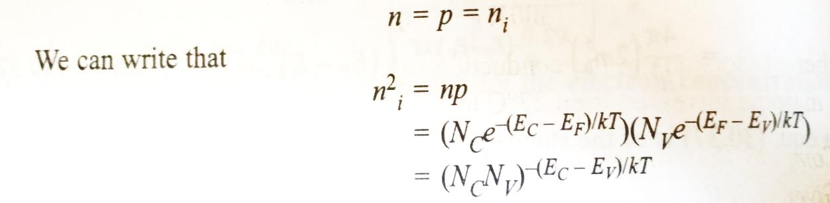

Thus the term Ec - Ev stands for the difference between top of the valence and bottom the conduction band. Thus it represents the band gap of the material (Eg).

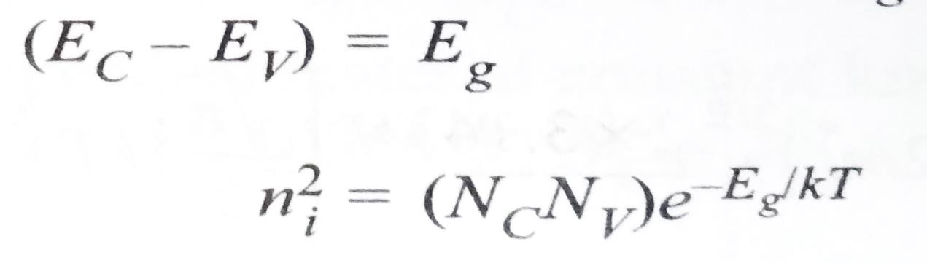

Then the by substituting the values of Nc and Nv in the above equation we obtain

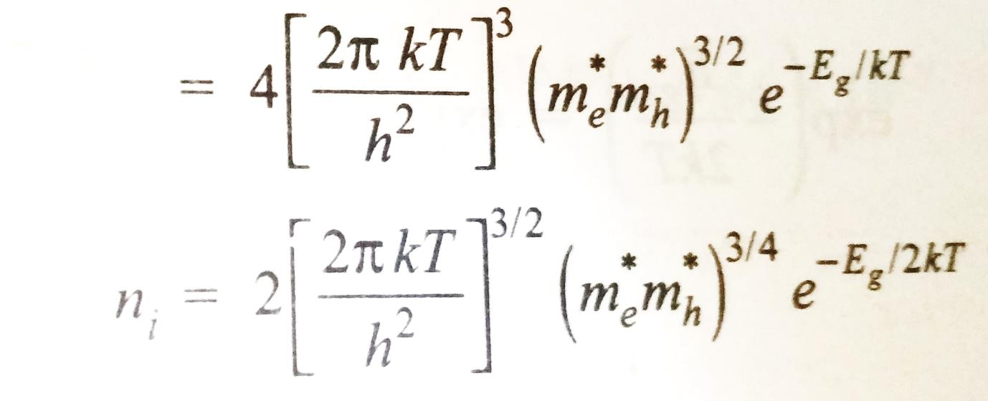

This is the expression for intrinsic carrier concentration.

**Variation of Intrinsic carrier concentration with temperature**

The equation of intrinsic carrier concentration can be re written as:

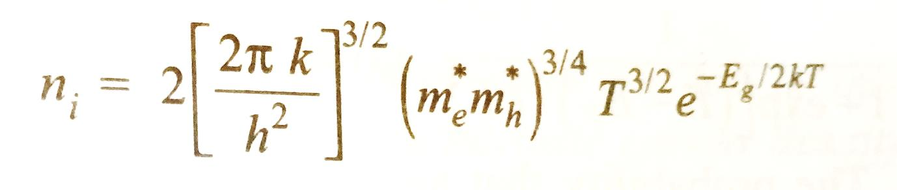

The above relation indicates that the carrier concentration varies with temperature. The following important points may be inferred from the above relation:

1. The intrinsic concentration is independent of the Fermi level
2. The intrinsic concentration depends exponentially on the band gap value.
3. The intrinsic concentration also strongly depends on the temperature
4. The factor 2 in the exponent indicates that two charge carriers are created when one covalent bond is broken.

**Carrier Concentration in n-type semiconductor at low temperatures:**

Let ND be the concentration of donors in the material. At 0K, the donor atoms are not ionized and are at the level ED which is very near to EC. When the temperatures raised above 0K, the donor atoms get ionized and free electrons appear in the conduction band. With increase in temperature more and more atoms get ionized and electron concentration in conduction band increases. Electrons require an energy ED, for their transition in the conduction band from the donor levels. Therefore, we assume the electron concentration n in the conduction band is

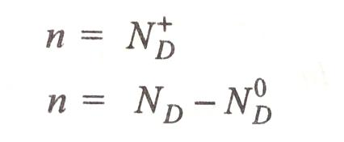

Where ND+ is the number donor atoms that have ionized and ND0is the number of atoms left to be ionized at the energy level ED.

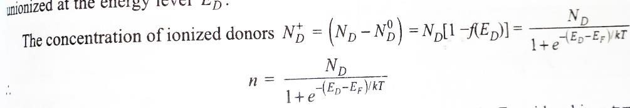

From the operational definition of fermi level it is expected that the fermi level in n-type semiconductor lies in a few kT above ED. Therefore, the above equation may be simplified as

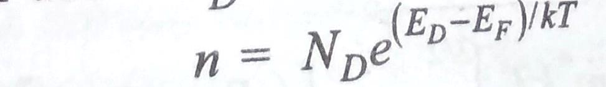

But the electron concentration n in the conduction band is given by

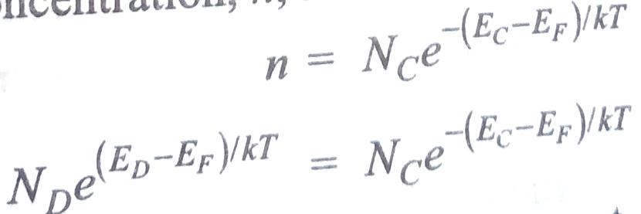

Taking logarithm and rearranging the terms we get

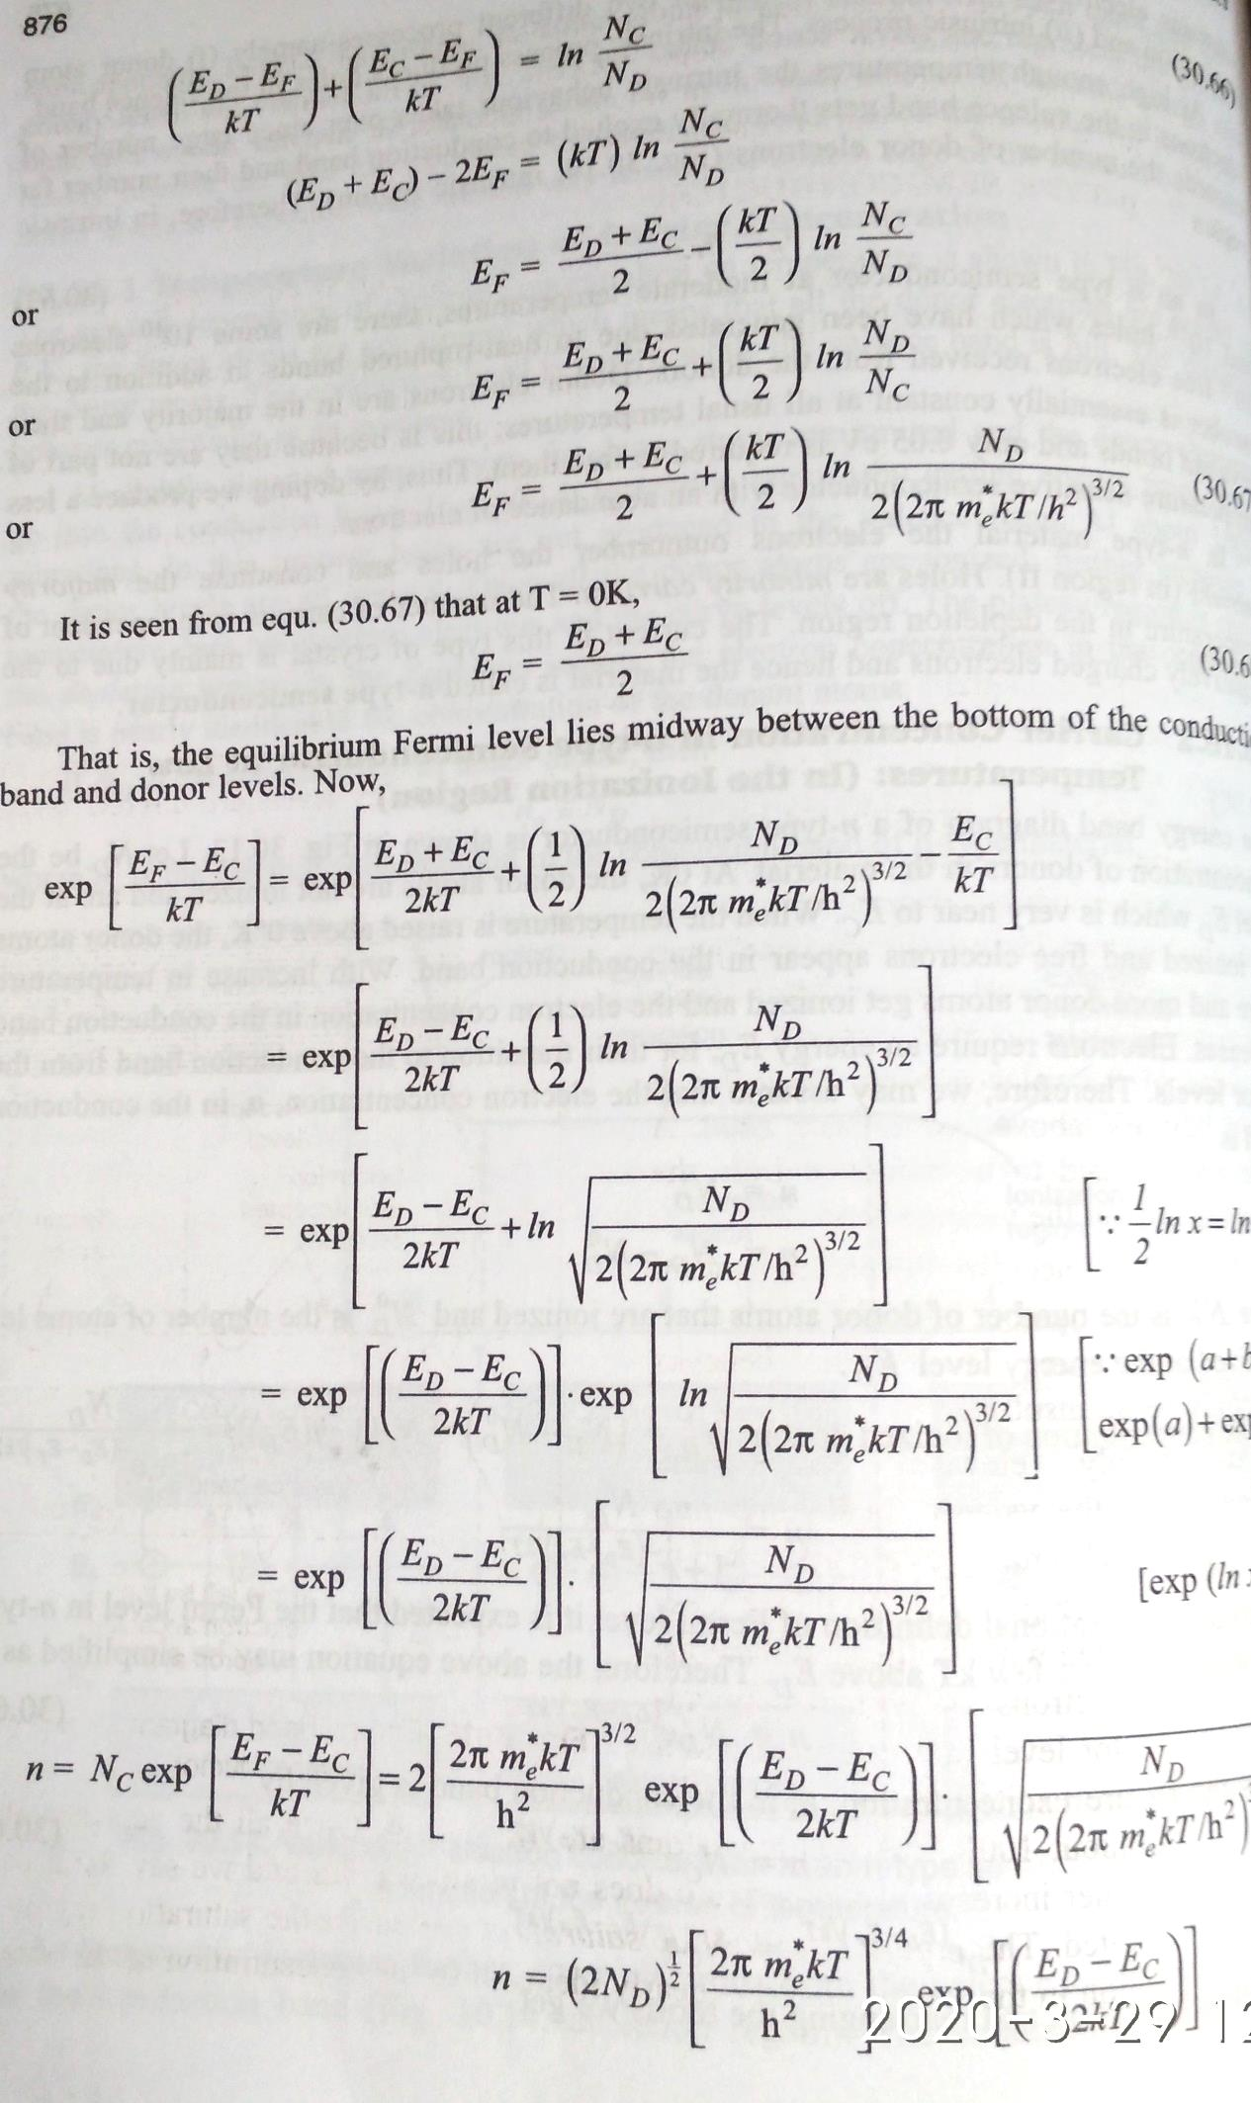

**Fermi level:**

Fermi level is the term used to describe the top of the collection of electron energy levels. This concept comes from Fermi-Dirac statistics.

The Fermi level is the average electrons that are available ( electrochemical potential for electrons) and is usually denoted by µ or EF .The Fermi level of a body is a thermodynamic quantity, and the thermodynamic work required to add one electron to the body (not counting the work required to remove the electron from wherever it came from).

● Fermi level is defined for any temperature.

● Fermi level is a total energy level including kinetic energy and potential energy.

● Fermi level (the electrochemical potential of an electron) remains well defined even in complex interacting systems, at thermodynamic equilibrium.

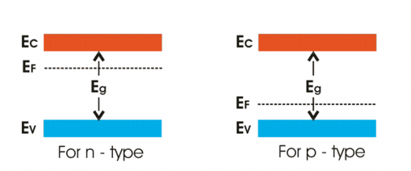

**Fermi Energy:**

The Fermi energy is a concept in quantum mechanics usually referring to the energy difference between the highest and lowest occupied single-particle states in a quantum system of non-interacting electrons (Fermions) at absolute zero temperature.

● The Fermi energy is only defined at absolute zero

● The Fermi energy is an energy difference (usually corresponding to a kinetic energy)

● The Fermi energy can only be defined for non-interacting particles ( Fermions where the potential energy or band edge is a static, well defined quantity)

**Fermi-Dirac Distribution**

● The probability of occupation

● It applies to fermions (½ spin quantum number). Other fermions include protons, neutrons, certain atoms, etc.

● T = 0 K, step function, step at Fermi level

● T > 0K, finite probability near Fermi level

**Variation of Fermi level with impurity concentration**

**N-Type semiconductor:**

The addition of donor impurity to an intrinsic semiconductor leads to the formation of discrete donor levels below the bottom edge of the conduction band. At lower concentration of doping, the impurities level are well spaced from each other and they do not interact with each other. But at higher level of concentration the separation between the levels decreases which creates a tendency to interact among the atoms. Due to this formation of band occurs below the conduction band (which means splitting of energy levels collapse). If further doping is done there is a possibility that there will be an overlapping of band (due to dopants) with that of conduction band. Thus the upper vacant levels in the conduction band are accessible to the donor electrons. Due this broadening the width of the forbidden gap decreases and thus the Fermi level displaces upward which in turn shifts the Fermi level closer to the conduction band.

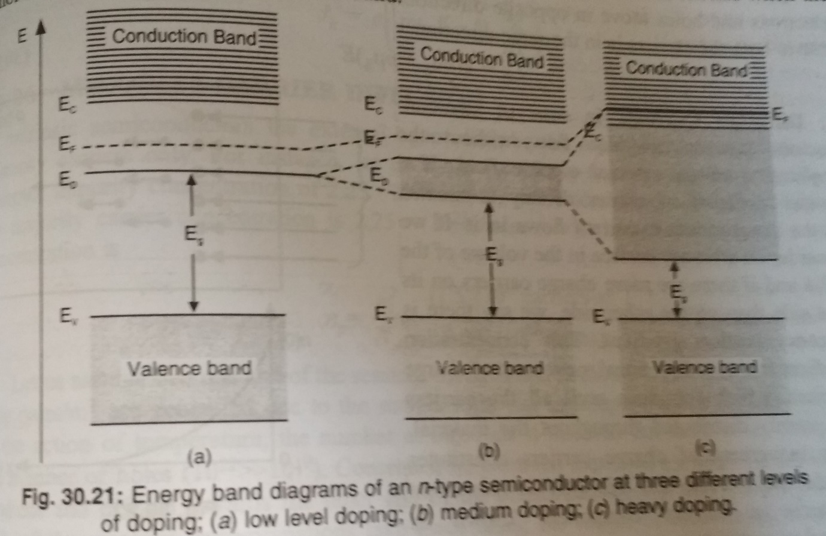

**P-Type semiconductor:**

In case of p-type semiconductor the acceptor levels broaden and form into a band with increasing impurity concentration. Thus the acceptor band finally collapses with the valence band. In this process the Fermi level lowers down towards the valence band.

**Variation of Fermi level with Temperature**

**N-Type semiconductor:**

In N-type semiconductor at low temperatures, some donor atoms are ionized and provide electrons to the conduction band while others remain neutral. As the electrons in the conduction band are only due to the transitions from the donor levels, the Fermi level must lie

between the impurity donor levels and bottom of the conduction band. When T = 0 K, Efn lies midway between the donor levels and the bottom the conduction band. Thus,

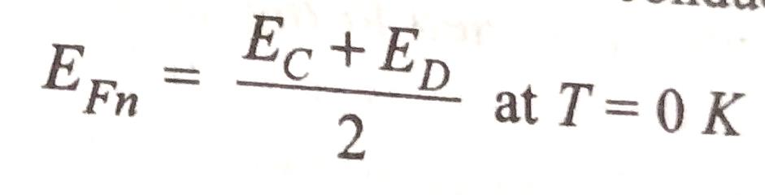

As the temperatures increases the donor level gradually get depeleted and fermi level goes down. At the temperature of complete depletion of donor levels Td, the fermi level coincides with the donor level ED

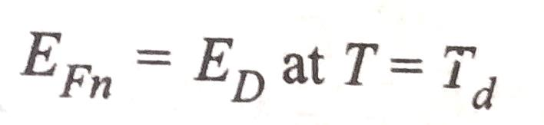

As the temperature grows further above Td, the fermi level shifts down in a linear fashion. At a temperature Ti, the intrinsic process contributes to electron concentration significantly. Thus at higher temperatures the n-type semiconductors behaves like a intrinsic semiconductor instead of an extrinsic semiconductor. Thus

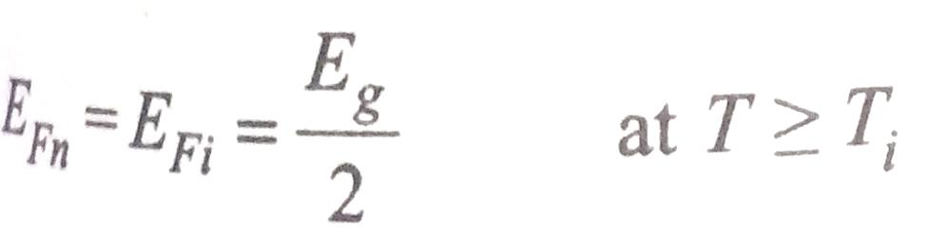

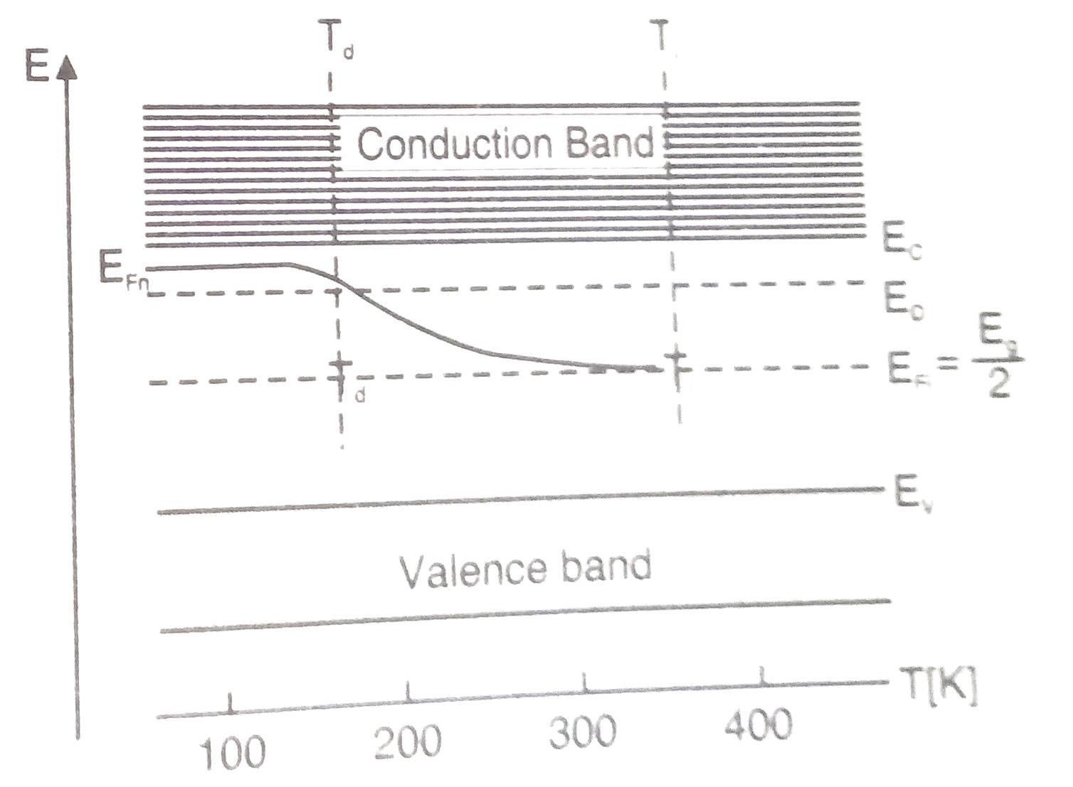

**P-Type semiconductor:**

In P-type semiconductor at low temperatures, holes in the valence band are only due to the transitions of electrons from the valence band to acceptor levels. As the valence band is the source of electrons and the acceptor levels as the recipient of them, Fermi level thus lie

between the impurity acceptor levels and top of the valence band. When T = 0 K, Efp lies midway between the acceptor levels and the top of conduction band. Thus,

**Efp = (Ev + EA)/2**

As the temperatures increases the acceptor level gradually get filled and fermi level goes upward. At the temperature of complete saturation of acceptor levels Ts, the fermi level coincides with the donor level EA

**Efp = EA at T = Ts**

As the temperature grows further above Ts, the fermi level shifts upward in a linear fashion. At a temperature Ti, the intrinsic process contributes to hole concentration significantly. Thus at higher temperatures the p-type semiconductors behaves like an intrinsic semiconductor instead of an extrinsic semiconductor. Thus

**Efp = Ei = Eg/2 at T = Ti**

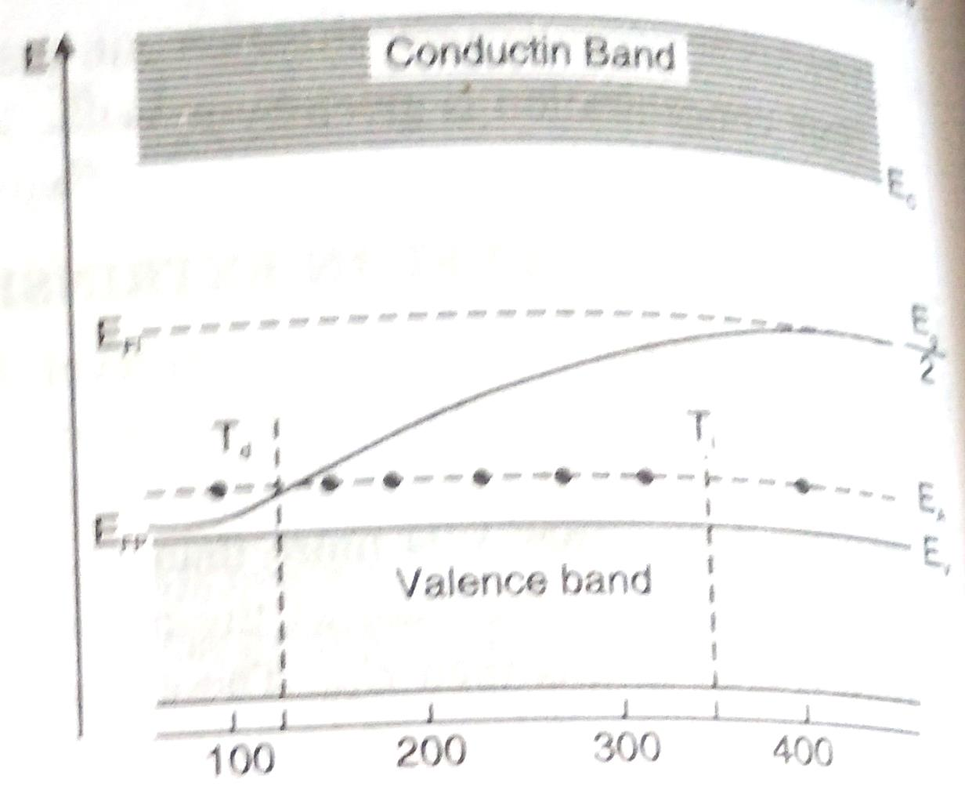

**Direct and Indirect band gap Semiconductors**

**Band Gap**

The band gap represents the minimum energy difference between the top of the valence band and the bottom of the conduction band. However, the top of the valence band and the bottom of the conduction band are not generally at the same value of the electron momentum.

**Direct Band Gap**

In a direct band gap semiconductor, the top of the valence band and the bottom of the conduction band occur at the same value of momentum, as in the schematic below.

|  |
| --- |
| <http://1.bp.blogspot.com/-jU4oBmkjXl0/UNAn6K10r4I/AAAAAAAACXw/jrrEW9y9jTo/s1600/direct_bandgap.jpg> |
| Direct Band Gap |

When an electron sitting at the bottom of the Conduction Band recombines with a hole sitting at the top of the Valance Band, there will be no change in momentum values.  Energy is conserved by means of emitting a photon, such transitions are called as radiative transitions. Direct band gap semiconductors are capable of photon emission, by radiative recombination, but indirect semiconductors have a low probability of radiative recombination.

**Indirect Band Gap**

In an indirect band gap semiconductor, the maximum energy of the valence band occurs at a different value of momentum when comparing with the minimum in the conduction band.

|  |
| --- |
| <http://1.bp.blogspot.com/-EJBVTGpB1mc/UNAob6ysUGI/AAAAAAAACX4/S4PRtV5_Fuo/s1600/indirect_bandgap.jpg> |
| Indirect Band Gap |

For an indirect-band gap material; the minimum of the CB and maximum of the VB lie at different k-values. When an e- and hole recombine in an indirect-band gap s/c, phonons must be involved to conserve momentum. In indirect band gap semiconductors may have iso electronic impurity states or Defect state which are direct, and therefore the recombination from these states may also be radiative.

**Phonon**

* Atoms vibrate about their mean position at a finite temperature.These vibrations produce vibrational waves inside the crystal.
* Phonons are the quanta of these vibrational waves.
* Phonons travel with a velocity of sound.
* Their wavelength is determined by the crystal lattice constant. Phonons can only exist inside the crystal.

So in order to have efficient LED’s and LASER’s, one should choose materials having direct band gaps such as compound Semi Coductors of GaAs, AlGaAs, etc…

**The below table show the properties of various Semiconductor materials**

|  |  |  |  |
| --- | --- | --- | --- |
|  | **Material** | **Direct / Indirect Bandgap** | **Band Gap Energy at 300 K (eV)** |
| **Elements** | **C (diamond) Ge Si Sn** | Indirect Indirect Indirect Direct | 5.47 0.66 1.12 0.08 |
| **Groups III-V compounds** | **GaAs InAs InSb GaP GaN InN** | Direct Direct Direct Indirect Direct Direct | 1.42 0.36 0.17 2.26 3.36 0.70 |
| **Groups IV-IV compounds** | **α-SiC** | Indirect | 2.99 |
| **Groups II-VI compounds** | **ZnO CdSe ZnS** | Direct Direct Direct | 3.35 1.70 3.68 |

**Hall Effect**

Background:

In this experiment, the Hall Effect will be used to study some of the physics of charge transport in metal and semiconductor samples.

In 1879 E. H. Hall observed that when an electrical current passes through a sample placed in a magnetic field, a potential proportional to the current and to the magnetic field is developed across the material in a direction perpendicular to both the current and to the magnetic field. This effect is known as the Hall effect, and is the basis of many practical applications and devices such as magnetic field measurements, and position and motion detectors.

With the measurements he made, Hall was able to determine for the first time the sign of charge carriers in a conductor. Even today, Hall effect measurements continue to be a useful technique for characterizing the electrical transport properties of metals and semiconductors. Indeed, the failure of the simple model of metallic conductivity, which we discuss below, to account for many experimental measurements of the Hall effect has been one of the principal motivators leading to a better understanding of electronic properties of materials.

Consider a conducting slab as shown in Fig. 1 with length L in the x direction, width w in the y direction and thickness t in the z direction.

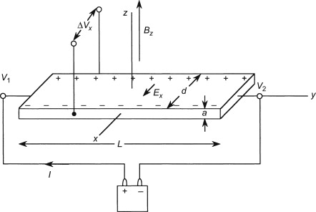

Figure 1

Assume the conductor to have charge carrier of charge q (can be either positive or negative or both, but we take it to be of just one sign here), charge carrier number density n (i.e., number of carriers per unit volume), and charge carrier drift velocity vx when a current Ix flows in the positive x direction. The drift velocity is an average velocity of the charge carriers over the volume of the conductor; each charge carrier may move in a seemingly random way within the conductor, but under the influence of applied fields there will be a net transport of carriers along the length of the conductor. The current Ix is the current density Jx times the cross-sectional area of the conductor “da”. The current density Jx is the charge density *nq* times the drift velocity vx. In other words

Ix = Jxda = nqvxda.

The current Ix is caused by the application of an electric field along the length of the conductor Ex. In the case where the current is directly proportional to the field, we say that the material obeys Ohm’s law, which may be written

Jx = σEx

where σ is the conductivity of the material in the conductor. Now assume that the conductor is placed in a magnetic field perpendicular to the plane of the slab. The charge carriers will experience a Lorentz force q**v** × **B** that will deflect them toward one side of the slab. The result of this deflection is to cause an accumulation of charges along one side of the slab which creates a transverse electric field Ey that counteracts the force of the magnetic field. (Recall that the force of an electric field on a charge q is q**E**.) When steady state is reached, there will be no net flow of charge in the y direction, since the electrical and magnetic forces on the charge carriers in that direction must be balanced. Assuming these conditions, it is easy to show that

Ey = vxBz

where Ey is the electric field, called the Hall field, in the y direction and Bz the magnetic field in the z direction. In an experiment, we measure the potential difference across the sample—the Hall voltage VH— which is related to the Hall field by

VH = − = −Eyw .

From the above equations we obtain

VH = −

The term in parenthesis is known as the Hall coefficient: RH = . It is positive if the charge carriers are positive, and negative if the charge carriers are negative. In practice, the polarity of VH determines the sign of the charge carriers. Note that the SI units of the Hall coefficient are [m3/C] or more commonly stated [m3/A-s].

**Applications of Hall Effect:**

Hall effect is a very useful phenomenon and helps to Determine the Type of Semiconductor  
By knowing the direction of the Hall Voltage, one can determine that the given sample is whether [n-type semiconductor](https://www.electrical4u.com/n-type-semiconductor/) or [p-type semiconductor](https://www.electrical4u.com/p-type-semiconductor/). This is because Hall coefficient is negative for n-type semiconductor while the same is positive in the case of p-type semiconductor.

**Calculate the Carrier Concentration**  
The expressions for the carrier concentrations of electrons (n) and holes (p) in terms of Hall coefficient are given by  
https://www.electrical4u.com/images/march16/1463032511.GIF

**Determine the Mobility (Hall Mobility)**  
Mobility expression for the electrons (μn) and the holes (μp), expressed in terms of Hall coefficient is given by,  
https://www.electrical4u.com/images/march16/1463032613.GIF  
Where, σn and σp represent the [conductivity](https://www.electrical4u.com/electrical-conductivity-of-metal-semiconductor-and-insulator/) due to the electrons and the holes, respectively.

**Measure Magnetic Flux Density**  
This equation can be readily deduced from the equation of Hall voltage and is given by  
https://www.electrical4u.com/images/march16/1463032721.GIF  
Further, there are many commercially available types of equipment based on the principle of Hall effect including Hall-effect sensors and Hall-effect probes.